# Architecture Overview

## Overview

The Architecture Design Specification (ADS) supplies high level descriptions of different layers to be implemented in the MAVS system and provides the relationship between the different layers. The ADS helps the stakeholders understand the MAVS system and its architecture at higher level. The ADS furnishes the architectural test considerations the MAVS team will be taking into account.

The ADS does not contain any details about the implementation of the product other than the high level description of the architectural planning.

## Outline

Architecture Layer (Chapter 2): Names the different layers implemented in the MAVS System along with the brief descriptions of those layers

Inter-Subsystem Dataflow (Chapter 3): Describes the dataflow between the subsystems

Individual Layers (Chapters 4 – 7): Breaks down each layer into different subsystems and describes each subsystem and its features

Testing Considerations (Chapter 8): Describes MAVS Team’s test standards and how each architectural layer of the MAVS System will be tested

## Purpose

The purpose of the ADS is to define the architecture specifications for the MAVS System. The ADS allows MAVS Team to further breakdown the components of the product into mini-components to be completed throughout the life of the project. The ADS is the first step in the implementation of the product and will serve as a guideline.

The ADS does not describe individual components of the MAVS system nor does it explain how MAVS Team will implement the components. The ADS document sets up a foundation to initiate the implementation as the team moves to detail design phase.

## Project Scope

The MAVS System is a security system that gives the user total control and full capabilities concerning monitoring. The MAVS System is triggered primarily by sensors configured to the user’s specifications.  The user can access streaming video and audio from an on-site camera with their mobile device.  The user can also access these features from a central computer located on-site. The user can control the camera, configure the system settings, or instantly alert police to an emergency situation through a graphical interface from the mobile device. The MAVS System can be installed in homes, businesses, or any personal property with a secure point of entry.

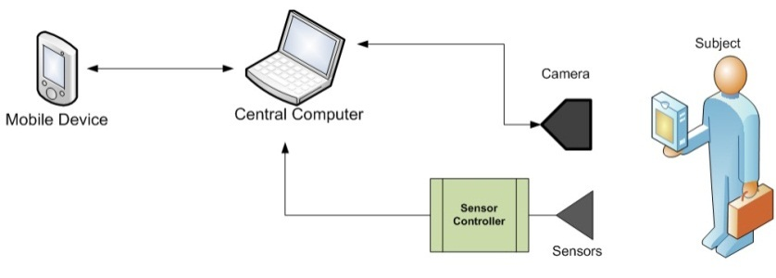

## System Requirements Mapping

Table 1 - Requirements Mapping

|  |  |  |  |  |  |
| --- | --- | --- | --- | --- | --- |
|  | **Customer Requirements** | **Control Layer** | **Sensor Layer** | **Camera Layer** | **Mobile Layer** |
| **4.2.1** | Mobile Device shall communicate with server |  |  |  |  |
| **4.2.2** | User is notified upon event (based on profile) |  |  |  |  |
| **4.2.3** | Authentication is necessary in order to access/control alarm |  |  |  |  |
| **4.2.4** | Camera and sensors are monitored by central server |  |  |  |  |
| **4.2.5** | User has the ability to control system status from Android device |  |  |  |  |
| **4.2.6** | Door/Window sensor must communicate with integrated circuit |  |  |  |  |
| **4.2.7** | System will handle user unavailability |  |  |  |  |
| **4.2.8** | System shall have an GUI for mobile device |  |  |  |  |
| **4.2.9** | Video streamed to mobile device |  |  |  |  |
| **4.2.10** | User can control camera from mobile device |  |  |  |  |
| **4.2.11** | User can dial 911 with one button |  |  |  |  |
| **4.2.12** | User is notified of connections status |  |  |  |  |
| **4.2.13** | User can view archived video |  |  |  |  |
| **4.2.14** | The user can set pre-defined camera "zones". |  |  |  |  |
| **4.2.15** | The system shall stream audio to the mobile device |  |  |  |  |
| **4.2.16** | User can set alert profile from mobile device |  |  |  |  |
| **4.2.17** | Detailed logs saved on server |  |  |  |  |
| **4.2.18** | Automatic lights on events |  |  |  |  |
| **4.2.19** | User can transmit voice to home |  |  |  |  |
| **4.2.20** | System deals with power outages |  |  |  |  |

## Definitions, Acronyms and Abbreviations

CSE – Computer Science and Engineering

IC - Integrated Circuit

IEEE – Institute of Electrical and Electronics Engineers.

MAVS System – Maverick Audio Visual Security System. Name of the product.

MAVS Team – Maverick Audio Visual Security Team. Name of the Team.

SC - Sensor Controller

SOG – Standard Operating Guidelines.

SOP – Standard Operating Procedure.

SRD – System Requirements Document.

User – Refers to the property owner, manager, or security personnel

UPS - Uninterruptible Power Supply

UTA – University of Texas at Arlington.

Subject -- Refers to an entity capable of triggering the alarm.

Mobile Device -- Refers to any mobile device or tablet running Android 2.0 or greater

POE -- Point of Entry. Refers to a structural feature on a property through which persons or animals enter and exit the property, such as doors or windows.

# Testing Considerations

## General

Testing considerations cover the paths needed to test the MAVS System layers directly associated with the customer requirements. The testing procedures include unit testing, component testing, integration testing, and system verification testing.

* Unit testing consists of black box testing of each subsystem. Unit testing supplies subsystems with predetermined values designed to generate specific results to determine the usability of the subsystem.
* Integration testing is the process of verifying the interaction between the layers. Subsystems are assembled and tested in a group to verify performance and reliability of the system.
* System testing is the testing of a complete system after incorporation of the layers.

## Layer-level Interactions

The layers of the MAVS System are designed in modules and can be tested independently as well as together. The layer-level interactions clarify the standards of how testing is performed.

### Control Layer

* The Control Layer consists of an Integrated Circuit that handles the sensors. The Integrated Circuit will then send a signal to

### Sensor Layer

* MORE INFO

### Camera Layer

* MORE INFO

### Mobile Layer

* MORE INFO

## Assumptions

### Subsystem pass/fail criteria

Subsystems will pass the testing phase after exhibiting the expected behavior.

### Test deliverables

The test results will be recorded.

### Staffing and training needs

The System Test Plan will provide instructions for testing all features of the MAVS System. The MAVS Team members will be able to test entire system by following the System Test Plan.

### Debugging and Logging

The Mobile Interface and Control layers will record failures in their respective log files.

## Testing Considerations

### Independence

The independence of each layer will be accomplished by testing each layer independently. Some of the testing will be black box testing.

### Integrity

The completeness of the architecture will be verified during system testing. The MAVS System will be assembled and tested as a whole system to verify the integrity of the system.

### Interfaces

After unit testing, the subsystems will be coupled together to verify the interfaces. Similarly, the layers will be assembled to verify the layer interfaces.

### Implementability

MAVS Team will use well documented software and hardware to maintain the implementability of the MAVS System.